# SINGAPORE POLYTECHNIC

|  |
| --- |
| Warning: Plagiarism means passing off as one's own the ideas, works, writings, etc., which belong to another person. In accordance with this definition, you are committing plagiarism if you copy the work of another person and turning it in as your own, even if you would have the permission of that person. Plagiarism is a serious offence and disciplinary action will be taken against you. If you are guilty of plagiarism, you may fail all modules in the semester, or even be liable for expulsion. |

|  |  |  |
| --- | --- | --- |
| **Module Code** | **:** | ST2414 |
|  |  |  |
| **Module Name** | : | Programming in Security |
| **Acad Year/Semester** | **:** | AY24/25 Semester 1 |
|  |  |  |
| **Set by** | **:** | PSEC Teaching Team |
|  |  |  |
| **Assignment Title** | **:** | CA1-2 |
|  |  |  |
| **Assignment Type** | **:** | Individual |
|  |  |  |
| **Weighting** | **:** | CA1-2 40% of CA1 |
|  |  |  |
| **Deadline** | **:** | CA1-2 – **Mon 05/08/24, 08:00am (Week-17)** |
|  |  |  |
| **Submission Requirements** | **:** | You are required to submit **one** zip file (e.g., CA1-2.zip) via POLITEMALL. The zip file should include:   1. Scripts, user guides and system documentation. 2. Declaration of Academic Integrity (SOC). You can download the document [here](https://docs.google.com/document/d/1VN9rKHillHxL_5qt5LW2aGkBdka7zST_/edit?usp=sharing&ouid=102437809368940336947&rtpof=true&sd=true).   Multiple submissions are allowed, but only the most recent submission is kept. You must ensure that the correct file is submitted. |
| **Late submission** | **:** | 50% of the marks will be deducted for assignments that are received within one (1) calendar day after the submission deadline. No marks will be given thereafter.  Exceptions to this policy will be given to students with valid LOA on medical or compassionate grounds. Students in such cases will need to inform the lecturer as soon as reasonably possible.  Students are not to assume on their own that their deadline has been extended. |
| **Interview** | **:** | The interview will be conducted during the timetabled periods in **Week-17 (05/08/24 to 09/08/24).** You are expected to explain the program logic and modify the program during the interview.  **If you are absent from the interview without approved LOA, you will receive zero mark for the assignment.** |

**Info Security Scripts**

1. **Objective**

The objective of this assignment is for the student to develop some info secuirty scripts.

1. **Overview**

The main menu allows user to select one of the apps.

|  |
| --- |
| ** PSEC Info Security Apps **   1. Scan network 2. Upload/download file using FTP 3. Send custom packet 4. Quit |

* 1. Scan network

Study [nmap-scan-sample.py](https://ichatspedu-my.sharepoint.com/:u:/g/personal/quek_chee_siong_ichat_sp_edu_sg/Eeb7_mOQnklAmhgXPoakMu8BNLNtq5bFIAyMzzuZabesaQ?e=vhJNuK). The requirements are:

1. Target IP: localhost scanme.nmap.org
2. Ports: Top 10 ports
3. Protocols: TCP and UDP
4. Enable OS and version detection, script scanning, and traceroute

You are required to develop a port scanner (nmap-scanner.py) to display the output as shown in the sample below.

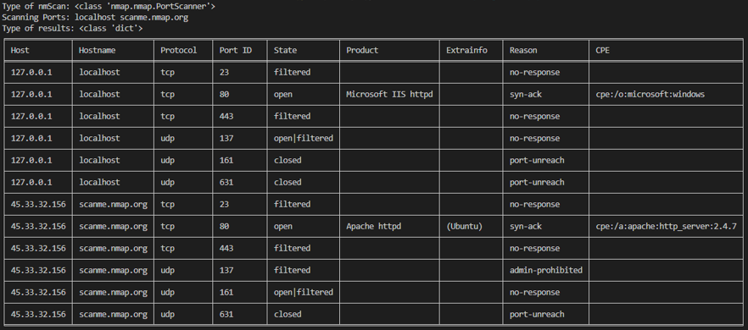

* 1. Upload/download file using FTP

Study [ftp-server-sample.py](https://ichatspedu-my.sharepoint.com/:u:/g/personal/quek_chee_siong_ichat_sp_edu_sg/EWiAO3J6_kNImR5KthER8iQBUFXlO3krjn3x_Tcd-hxlRg?e=oGbn76) and [ftp-client-sample.py](https://ichatspedu-my.sharepoint.com/:u:/g/personal/quek_chee_siong_ichat_sp_edu_sg/EawcbQ9DUZZFuY1yN-oZcrAB3vF5v0h9dx1OnKXnODi64g?e=yEYlYL). The requirements are:

1. ftp server that supports upload and download of various types of files, such as text, json and excel formats.
2. Able to specify home directory of server
3. Able to specify home directory of client

You are required to develop the ftp server/client (ftp-server.py and ftp-client.py).

Upload/Download file

1. Run the ftp server and display the output as shown in the sample below.

1. Provide an option to upload/download file.

Home directory of ftp server: ftpServerData

Home directory of ftp client: ftpClientData

1. Close the ftp session after downloading file as shown below.



If there are any errors, display 'Error in downloading: <filename>'.

Upload file

1. Close the ftp session after uploading file as shown below.



1. If there are any errors, display 'Error in uploading: < filename >'.
   1. Send custom packet

Study [send-custom-packet-sample.py](https://ichatspedu-my.sharepoint.com/:u:/g/personal/quek_chee_siong_ichat_sp_edu_sg/ET7l99KQxKRLjJBO1j5mJF8BLWL7jSapv-nIcg8s9-B5mA?e=TX6wjU). Run this script with the following inputs:

1. src_addr = 'www.sp.com'
2. src_port = 3000
3. dest_addr = 'www.pp.com'
4. dest_port = 5666
5. pkt_type = 'I'
6. Packet RAW Data (optional, DISM-DISM-DISM-DISM left blank): <Enter>
7. No of Packet to send (1-65535): 5

You can verify that the packet was sent using Wireshark as shown below.

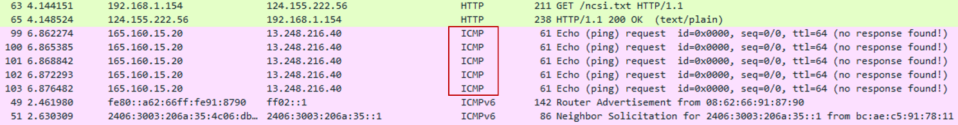

You should be able to verify the source and destination IP addresses.

You are required to develop the custom‐packet.py script and run it with above inputs except that

pkt_type = 'T'. All inputs must be validated, and you must check the URL format using regular

expression.

You are required to test with the following src and dest addresses:

1. src_addr = 'www.sp.com' or 'http://www.sp.com'
2. dest_addr = 'www.pp.com' or 'http://www.pp.com'

Verify that the packet was sent using Wireshark and submit the screen shot and *packets.pcapng file.

1. **User testing**
   1. Comprehensive tests

You are required to show the **comprehensive** tests performed for each script. Provide the screen shots for execution of each script.

* 1. Grading your scripts

Tutors will run your scripts and any **abnormal termination** will be severely penalized. Some examples that may cause abnormal terminations are:

1. Invalid file name.
2. Error in opening files for reading or writing.
3. **Documentation**

You are required to add comments and docstring for scripts ad user-defined functions.A sample is shown in Annex-1.

1. **Deliverables**

Submit **ONE** *.zip file with all scripts and data files in **ONE** folder. Naming convention for zip file is <class>-<name.zip: 1B02-ChinChiaHo.zip.

Sub-folders are **not recommended** as it may be difficult to implement. In the past, the file path was not set up properly resulting in many abnormal terminations of scripts.

Tutors will only run the scripts in the folder that you have submitted.

You are required to submit the checklist in Annex-2.

1. **Assistance from Tutor**

You may consult tutors if you have any issues with the CA. However, your tutors will not debug scripts for you.

1. **Questions on CA**

You should clarify all issues during the tutorials. You may also post questions in MS Teams.

1. **Assessment Guidelines**

The assignment will be assessed based on the following criteria:

|  |  |  |
| --- | --- | --- |
|  | Program Run   * Compliance with requirements. * Correct computation and appropriate user prompts. * Appropriate validations | 45 |
|  | Program Design   * Meaningful identifiers and correct file path. * Code is organized and easy to read. * Appropriate data structures, such as list and dictionary. * Readability – Code is well organized and easy to read with appropriate comments, docstrings and named parameters. * Modular – Code is organized for reusability. Appropriate definition of functions. | 30 |
|  | Documentation in script | 15 |
|  | Question & Answer during interview | 10 |
|  |  | 100 |

***-- End --***

**Annex-1 Documentation for script**

Main Program

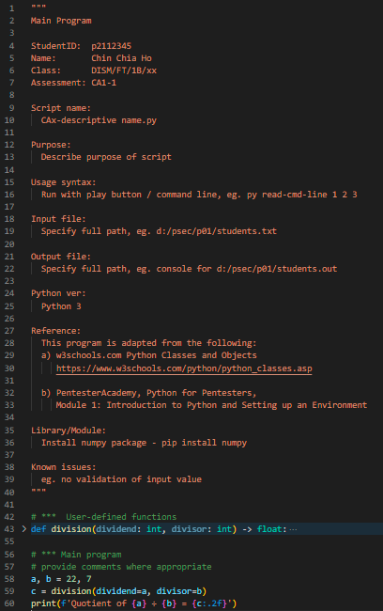

User-defined functions

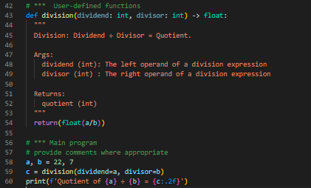

For each function, you must include the following:

1. Docstring (items between the """ quotes).
2. Named arguments, eg. dividend=a.

**Annex-2 Checklist for CA submission**

|  |  |
| --- | --- |
| **StudentID:**  **Name:**  **Class:**  **Assessment:** | p2109828  Ahmed Shaheed  DISM/FT/3A/39  CA1-2 |

**Checklist**

|  |  |  |
| --- | --- | --- |
| **No** | **Description** | **Remarks\*** |
| **1** | **Main menu to select the apps** | **100%** |
| 1.1 | Scan Network | **100%** |
| 1.2 | Upload/download file using FTP | **100%** |
| 1.3 | Send Custom packet | **100%** |
| **2** | **User testing**   1. Description of test data and the test 2. Screen shots | **100%** |
| **3** | **Documentation** for each script | **100%** |